Dawlance Inverter Split AC
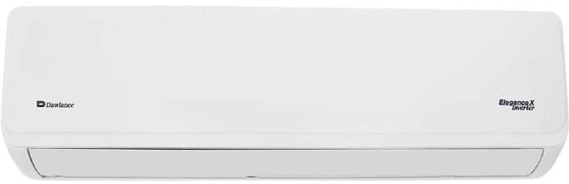
Rs.147,305
Dawlance Elegance X 1.5 ton inverter split AC is built for Pakistani summers with 4D airflow, low voltage operation, and efficient cooling for medium rooms.

Specifications
- Model: Elegance X
- Capacity: 1.5 Ton
- Cooling: 18,000 BTU/hr
- Voltage Range: 160V-260V

Key Features
- 4D airflow
- Fast cooling mode
- Heat and cool
- Gold fin condenser

